**Exercise: Over the hills and far away…**

In these exercises, you will work with the observer design pattern.

Tinky-Winky, Dipsy, La-la and Po live over the hills and far away.



They have not yet learned how to tell time, but fortunately, there is a big “voice trumpet” in the neighborhood, which tells them when to wake up, have dinner, and watch television and when to say tubbie-bye-bye.



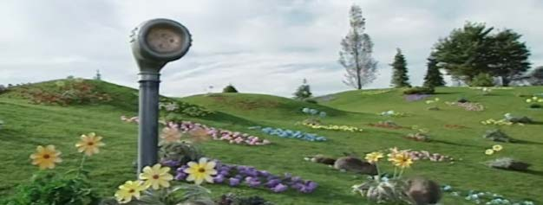

(image source[: https://www.youtube.com/watch?v=Uxm_wKsjoQU&t=606s)](https://www.youtube.com/watch?v=Uxm_wKsjoQU&t=606s)

**Exercise 1: (Design)**

Create a UML class diagram where you:

* Define the methods and properties of the teletubbies.
* Define the methods and properties of the voice trumpet. Note that the information the ‘trumpet’ has is the Activity that shall take place in Teletubbyland.
* Use the observer pattern to let the tubbies observe changes to the Activity and thereby know when to have dinner etc. Explain your design to one or two of your fellow students.

**Exercise 2: (Implementation)**

Implement your design as a Console application.

Control the voice trumpet from the main() method and have the tubbies write to the console, when they start doing something new.